# SDLC (Software Development Life Cycle) to Prepare a Software by using Steps.

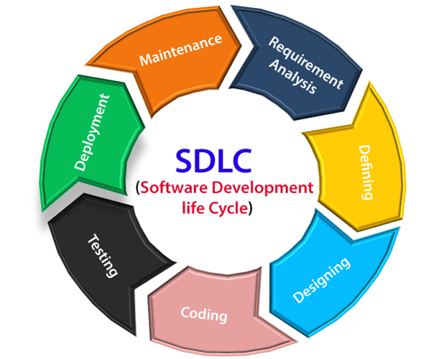

1. **Information Gathering Requirements:** Information gathering is the phase in the Software Development Life Cycle (SDLC) where project requirements are collected, analysed, and documented, typically involving interviews, surveys, research, and stakeholder collaboration to ensure a comprehensive understanding of user needs and project objectives.
2. **Analysis or Defining:** During this phase, the requirements gathered in the planning phase are analysed in detail. This involves understanding the needs of end-users, identifying any potential risks or constraints, and determining the feasibility of the project.
3. **Designing:** In this phase, the software architecture is designed based on the requirements and analysis. This includes defining the overall structure of the system, specifying individual components, and creating detailed design documentation.
4. **Coding and Implementation:** Also known as the development phase, this is where the actual coding takes place. Developers write the code according to the design specifications, following coding standards and best practices.
5. **Testing:** Once the code is written, it needs to be thoroughly tested to ensure that it meets the requirements and performs as expected. Testing can include unit testing, integration testing, system testing, and user acceptance testing.
6. **Deployment:** After the software has been tested and approved, it is deployed to the production environment. This may involve installing the software on servers, configuring it for use, and training end-users.
7. **Maintenance:** The final phase involves maintaining and supporting the software once it is in use. This includes fixing any bugs or issues that arise, making updates or enhancements as needed, and providing ongoing support to users.
8. **Example:** Movie Set, Military Preparation, Construct Building.

* To make Software we use some Patterns of Methods wo go with the flow of that Pattern for making a particular software.
* There are Two types of Method that are used widely in the it service sector. **1) Waterfall Model (That is a Traditional model) 2) Agile Process or Method (For Rapid Develop the work of the Software).**
* **Waterfall Model.**

The Waterfall Model is **a linear application development model that uses rigid phases: When one phase ends, the next begins**. Steps occur in sequence, and, if unmodified, the model does not allow developers to go back to previous steps (hence “waterfall”: Once water falls down, it cannot go back up).

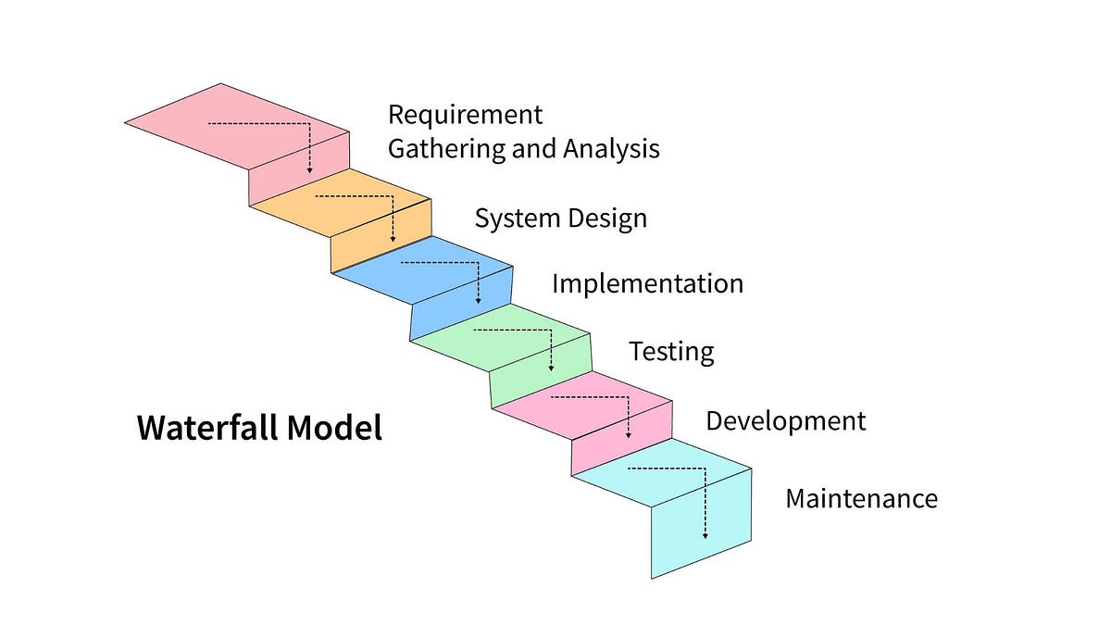

* **Agile Method.**

Agile development is important because **it helps to ensure that development teams complete projects on time and within budget**. It also helps to improve communication between the development team and the product owner. Additionally, Agile development methodology can help reduce the risks associated with complex projects.

